|  |  |
| --- | --- |
| Logo AGES | |
| Lamprodila festiva | |
|  |  |
| 09.05.2025 19:57 Uhr | |

**Lamprodila
festiva**

**Lamprodila
festiva
(synonym:
Palmar
festiva)**

Last
change:
29.10.2024

**Profile**

The
juniper
beetle
is
a
metallic
green
colored
beetle
that
is
common
on
its
main
host
plant,
the
juniper.
Although
the
very
splendidly
colored
beetle
is
considered
rare
and
is
therefore
on
the
red
list
in
Germany,
an
increasing
number
of
damages
have
been
registered
recently.
It
is
also
responsible
for
a
certain
proportion
of
damage
to
other
cypress
plants,
such
as
thuja.

**Appearance**

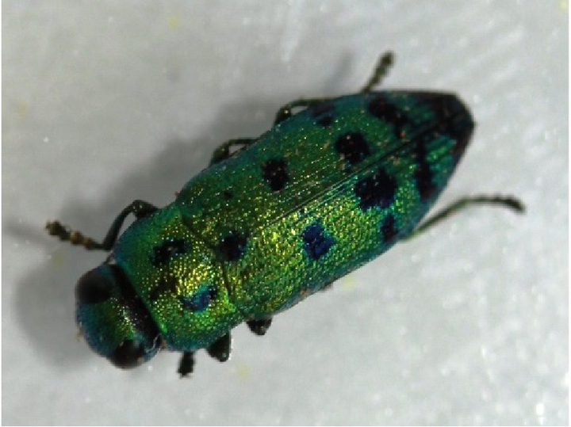

Wacholderprachtkäfer

The
metallic
green
shimmering
jewel
beetles
are
6-12
mm
long,
streamlined
and
show
steel
blue
spots
on
the
neck
shield
and
on
the
elytra.

The
cream-colored
larvae
are
15-20
mm
long,
legless,
and
show
strongly
sclerotized
mandibles
at
the
anterior
end.
The
anterior
part
of
the
thoracic
segment
is
strongly
broadened
compared
to
the
rest
of
the
narrow
body.

**Biology**

For
oviposition,
the
beetles
produce
a
short
cut
in
the
bark
with
their
ovipositor
and
lay
the
eggs
in
the
bast
between
the
bark
and
the
wood
body.
The
feeding
tunnels
of
the
larvae
are
usually
found
on
the
sunny
side
of
younger
shoots
and
branches
in
the
bast
and
superficially
in
the
wood
body.
These,
like
the
larvae
themselves,
have
a
flat
oval
cross-section
and
brown
bore
meal.
When
these
tunnels
completely
encircle
a
branch,
this
cuts
off
the
sap
flow
and
the
branch
dies.
After
overwintering
as
a
larva
in
deeper
layers
of
wood,
pupation
occurs
the
next
spring
in
a
small
cavity
made
vertically
in
the
wood.

In
early
summer
(around
the
time
of
the
linden
blossom),
an
adult
jewel
beetle
hatches
from
this
cavity,
thus
completing
the
cycle.
Only
one
generation
of
beetles
develops
per
year.

**Damage
symptoms**

The
juniper
beetle
causes
a
characteristic
pattern
of
damage
through
the
feeding
tunnels
of
its
larvae.
In
otherwise
healthy
looking
thuja,
individual
branches
die
and
turn
brown.
If
the
bark
of
such
dead
branches
is
cut
superficially,
the
cause
of
the
damage
becomes
visible.
Between
the
bark
and
the
body
of
the
wood
there
are
wide,
shallow
feeding
tunnels,
which
are
partly
filled
with
feeding
and
excrement
crumbs.
These
feeding
tunnels
cut
off
the
sap
flow
to
the
twigs,
and
the
green
scale
leaves
dry
out
and
turn
brown.
It
is
characteristic
that
only
individual
branches
always
turn
brown
and
not
the
entire
plant.
After
the
beetles
have
hatched,
the
infested
shoots
show
the
typical
transverse
oval
holes
up
to
5
mm
in
size.

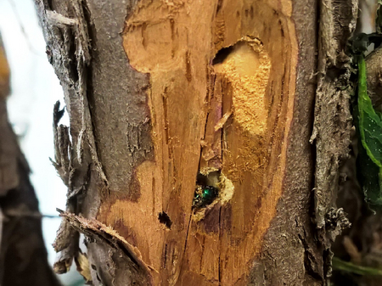

Bohrgang
unter
der
Rinde

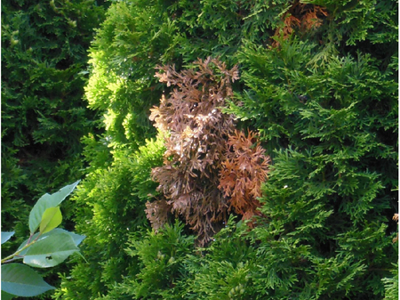

Schadbild

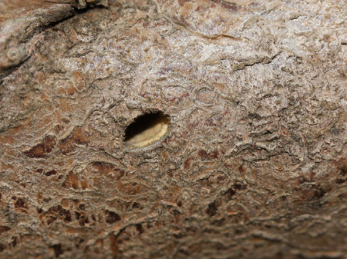

Ausbohrloch

**Host
plants**

Juniper
beetles
live
on
various
cypress
plants
of
the
genera
*Juniperus*,
*Thuja*,
*Cupressus*,
*Chamaecyparis*
and
*Platycladus*.

**Distribution**

The
beetle
originates
from
the
Mediterranean
region
and
has
spread
north
and
east
in
recent
decades.
Besides
Austria,
it
is
already
found
in
Germany,
the
Czech
Republic,
Hungary
and
Slovakia,
among
other
countries.

**Propagation
and
transmission**

It
is
believed
that
the
spread
of
the
juniper
jewel
beetle
is
favored
by
climate
change
and
its
spread
is
promoted
by
the
increasing
demand
for
cypress
plants
as
ornamentals
in
gardens.

**Economic
importance**

Due
to
the
fact
that
the
juniper
spotted
beetle
can
infest
not
only
stressed
but
also
healthy
plants
and
cause
them
to
die
within
two
to
three
years,
this
beetle
is
definitely
of
economic
importance
and
must
be
controlled
regularly,
especially
in
nurseries.

**Prevention
and
control**

* As
  a
  preventative
  measure,
  ensure
  that
  the
  plants
  have
  a
  good
  supply
  of
  water
  and
  nutrients,
  as
  weakened
  plants
  are
  more
  likely
  to
  be
  infested
* Cut
  out
  and
  destroy
  heavily
  infested
  plant
  parts
  (branches,
  twigs)
  before
  the
  beetles
  hatch
* Treatment
  with
  chemical
  preparations
  does
  not
  appear
  to
  make
  sense
* Judge
  on
  a
  case-by-case
  basis
  whether
  measures
  are
  necessary
  at
  all:
  after
  all,
  this
  is
  a
  very
  beautiful,
  hitherto
  rare
  beetle

**Services**

[Plant
Health
Services](en/plant/plant-health/plant-health-information)