|  |  |
| --- | --- |
| Logo AGES | |
| Common reed | |
|  |  |
| 04.07.2025 14:58 Uhr | |

**Common
reed**

**Phragmites
australis
[Cav.]
Trin.
ex
Steud.**

Last
change:
10.09.2024

**Profile**

Reed
canary
grass
occurs
only
occasionally
in
fields,
but
it
can
become
a
persistent,
troublesome
weed
with
high
levels
of
cover.

**Appearance**

The
species
is
a
rhizome
geophyte.
The
above-ground,
annual,
0.8-1.5
cm
thick
culms
grow
very
quickly
in
height
(2
to
4
m).
The
leaf
blades
appear
gray-green.
The
reed
is
a
panicle
grass
and
the
inflorescence
can
grow
up
to
40
centimeters
long.

**Distribution**

The
natural
habitat
of
the
reed
is
standing
waters,
but
also
wet
meadows
and
riparian
forests.
The
species
is
very
adaptable
and
occurs
on
road
embankments,
in
pavement
cracks
(!)
or
along
railroad
lines
and
even
in
fields.
Essentially
all
crops
such
as
corn,
soybean,
sugar
beet
and
cereals
are
affected.
Former
meadows
with
reed
beds
in
wetlands
that
have
been
converted
to
cropland
are,
of
course,
particularly
affected.
Once
reed
becomes
established,
it
also
colonizes
drier
sites
such
as
hillsides.

**Spread**

Local
spread
of
reed
is
based
on
the
vegetative
growth
of
rhizomes.
Thus,
the
plant
often
grows
from
the
edges
into
the
fields.
In
addition,
reed
can
spread
through
prostrate
culms
rooting
at
nodes.
Reed
is
most
likely
carried
from
field
to
field
via
rhizome
fragments.
The
role
of
seeds
in
colonizing
cropland
is
difficult
to
assess.

**Economic
importance**

The
species
reaches
heights
of
2
-
4
m
on
average
and
forms
extensive,
extremely
dense
stands,
but
mostly
only
partial
areas
of
a
field
are
affected.
The
competitive
effect
is
enormous
and
therefore
corresponding
yield
losses
are
to
be
expected.

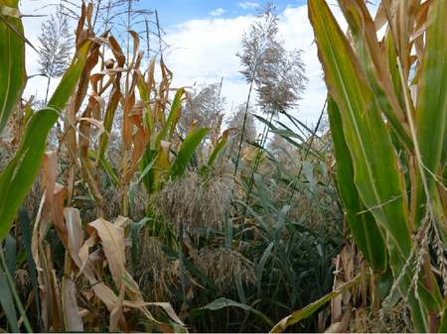

Das
Schilfrohr
in
Mais

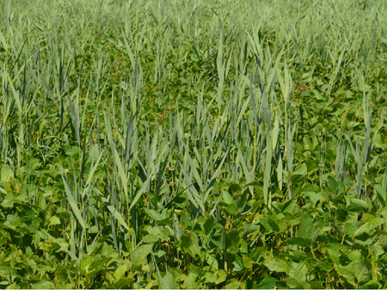

Das
Schilfrohr
in
Sojabohne

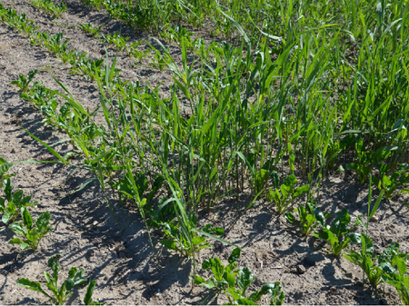

Das
Schilfrohr
in
Zuckerrüben

**Prevention
and
control**

Control
of
reed
canary
is
very
difficult
due
to
its
low-lying
rhizomes
and
high
regenerative
capacity.
The
choice
of
measures
is
limited
and
a
sustainable
success
is
not
always
given.

* Mechanical
  control
  can
  be
  done
  on
  the
  stubble
  or
  after
  harvest.
  The
  effect
  of
  repeated
  mechanical
  treatment
  measures
  is
  based
  on
  disruption
  of
  rhizome
  growth
  together
  with
  depletion
  of
  nutrient
  reserves
  and,
  above
  all,
  by
  working
  the
  rhizomes
  out
  to
  the
  soil
  surface
  with
  subsequent
  drying.
* The
  choice
  of
  suitable
  herbicides
  is
  very
  limited.
  The
  use
  of
  glyphosate-containing
  pesticides
  on
  the
  stubble
  so
  far
  provides
  the
  most
  consistent
  and
  also
  the
  longest
  lasting
  control
  of
  reed
  canary
  with
  suppression
  also
  in
  the
  following
  year.

**Specialized
information**

**Publications**

Follak,
S.,
2021.
problems
with
reeds
in
field
crops.
The
Plant
Physician
74(11-12),
26-27.

**Services**

[Plant
Health
Services](en/plant/plant-health/plant-health-information)